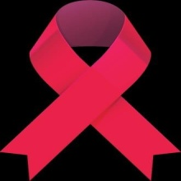
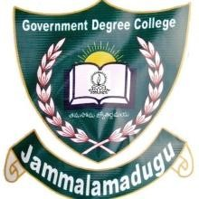
GOVERNMENT DEGREE COLLEGE JAMMALAMADUGU,KADAPA(DIST)

RED RIBBON CLUB
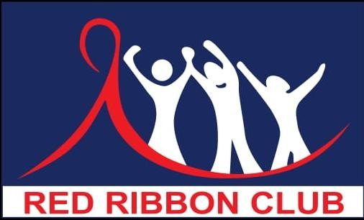

RRC Activity Report:2024-2025
Submitted By
Dr.V.Ravisekhar RRC Co-ordinator Supervision
By

Dr.A.C.R. Diwakar Reddy Principal
Government Degree College Jammalamadugu

Introduction

Red Ribbon is globally recognized symbol for HIV/AIDS awareness. Establishment of Red Ribbon Clubs was an important initiation undertaken by the Government of India to spread awareness about HIV/AIDS and associated myths among the youth and empower them as per educators. Red Ribbon was created in 1991 by the Visual AIDS Artists Caucus, New York, America

Red Ribbon Club is a voluntary on campus intervention is being implemented in the higher Education institution, aiming at heightening their risk perception and preventing HIV/AIDS as well as promoting voluntary blood donation among youth

Objectives
- To reduce new HIV infection through awareness
- To motivate youth and build their capacity by developing their skills on leadership and team building

- Sensitize the youth regarding care and support needs of people affected with HIV/AIDS and in still in them the spirit to reduce the stigma and discrimination against them

RRC Activities :
RRC Programme with the objective of bringing about behavior change in youth minds employs varies strategies like :
- Celebrating Life Programs
- Peer education and leadership training
- Cultural Competitions
- Awareness campaigns (Rallies, outreach activities)

Goals
To reduce the occurrence of new sexually transmitted infections, awareness on HIV/AIDS, to promote voluntary non-remunerated Blood Donation among youth

Message by Principal

Principal
Dr.A.C.R. Diwakar Reddy
M.Sc. Ph.D

I am very much delighted to learn that my College Red Ribbon Club cell is bringing out its RRC Activities Report for the year 2024-2025 showing revolutionary changes in the RRC activities. RRC volunteers have been creating awareness among the youth to uplift of Indian society. RRC cell of the Government Degree College, Jammalamadugu have been enthusiastically involving in the conducting of HIV/AIDS awareness programs, Blood donation programs for the welfare of the society
I congratulate the co-oridinator of RRC and other supporting staff and students for their cooperation towards society and also bringing out this Annual Report
Principal

Message by RRC coordinator
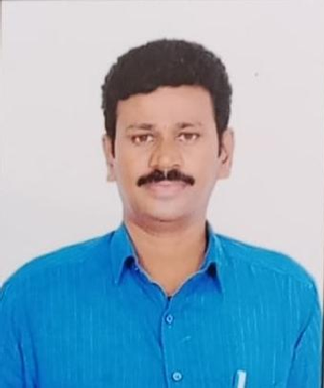

RRC,Coordinator Dr.V.Ravisekhar,M.Sc.,Ph.D

It is my honour and privilege to present report of RRC cell, Government Degree College, Jammalamadugu for the year 2024-2025. RRC aimed at developing student’s personality through awareness. As per RRC guidelines RRC cell has been conducted several activities.
By involving the members of RRC of the college, we conduct HIV/AIDS awareness programs, Essay writing, Elocution, Debate and some other activities
It gives immense pleasure to express my thanks to our college Principal, Dr.A.C.R. Diwakar Reddy garu, DMHO office and RRC Dist. coordinator, Kadapa

RRC Co ordinator

GOVT. DEGREE COLLEGE
JAMMALAMADUGU
KADAPA DISTRICT

ACTION PLAN
RED RIBBON CLUB PROGRAMME SCHEDULE

S.No | Programme Name | Tentative Date
1 | Membership Drive | 30/11/2024
2 | Peer group Selection(2/Section) | 30/11/2024
3 | Essay writting,Elocution and quiz programmes | 30/11/2024
4 | Rally on HIV/AIDS Awareness Programme | 01/12/2024
5 | Medical Camp awareness on Women Hygiene | 02/12/2024
6 | Guest Talk on Blood Transfusion & Health | 02/12/2024
7 | Life Skill awareness session | 03/12/2024
8 | Blood Group Determination | 05/12/2024
9 | HIV/AIDS Awareness Programme | 06/12/2024
10 | Visit to Positive NetWork Society | 07/12/2024
11 | Blood Donation | 09/12/2024

Membership Drive

Date: 30/11/2024

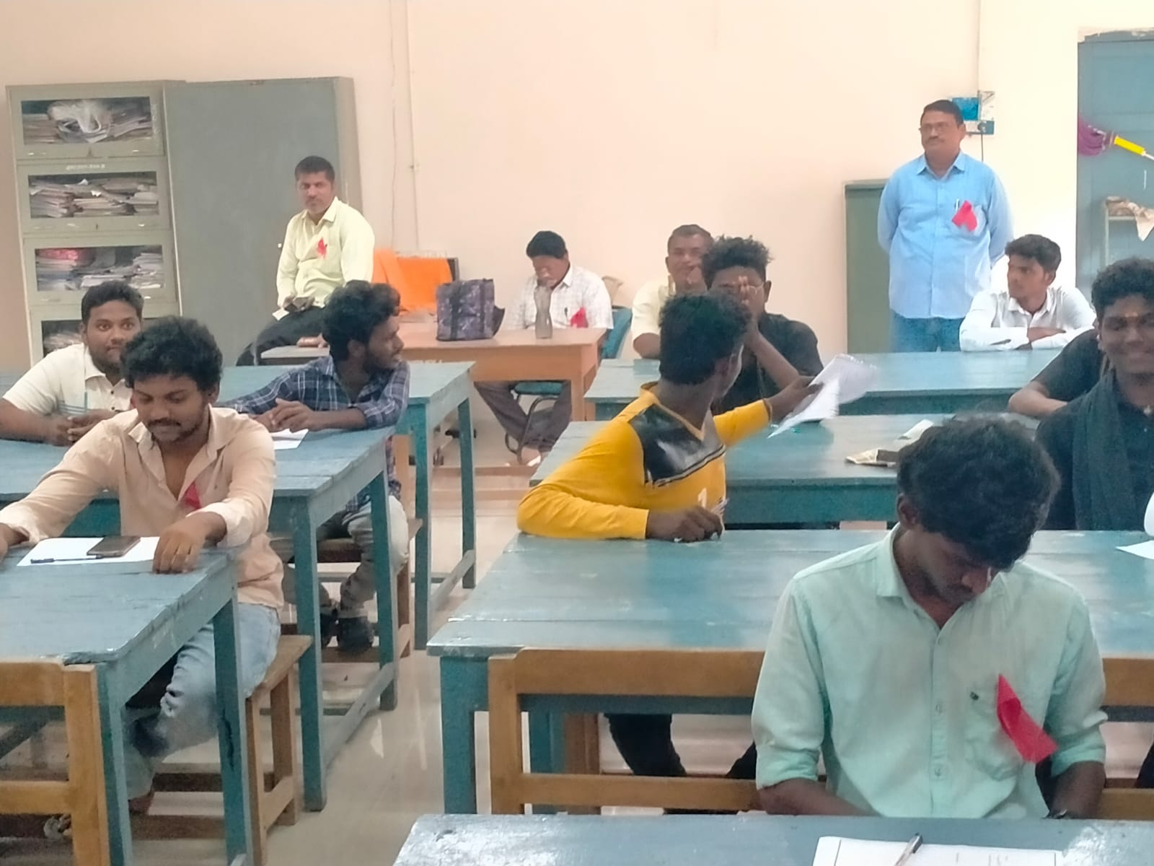

Peer Group selection

30/11/2024
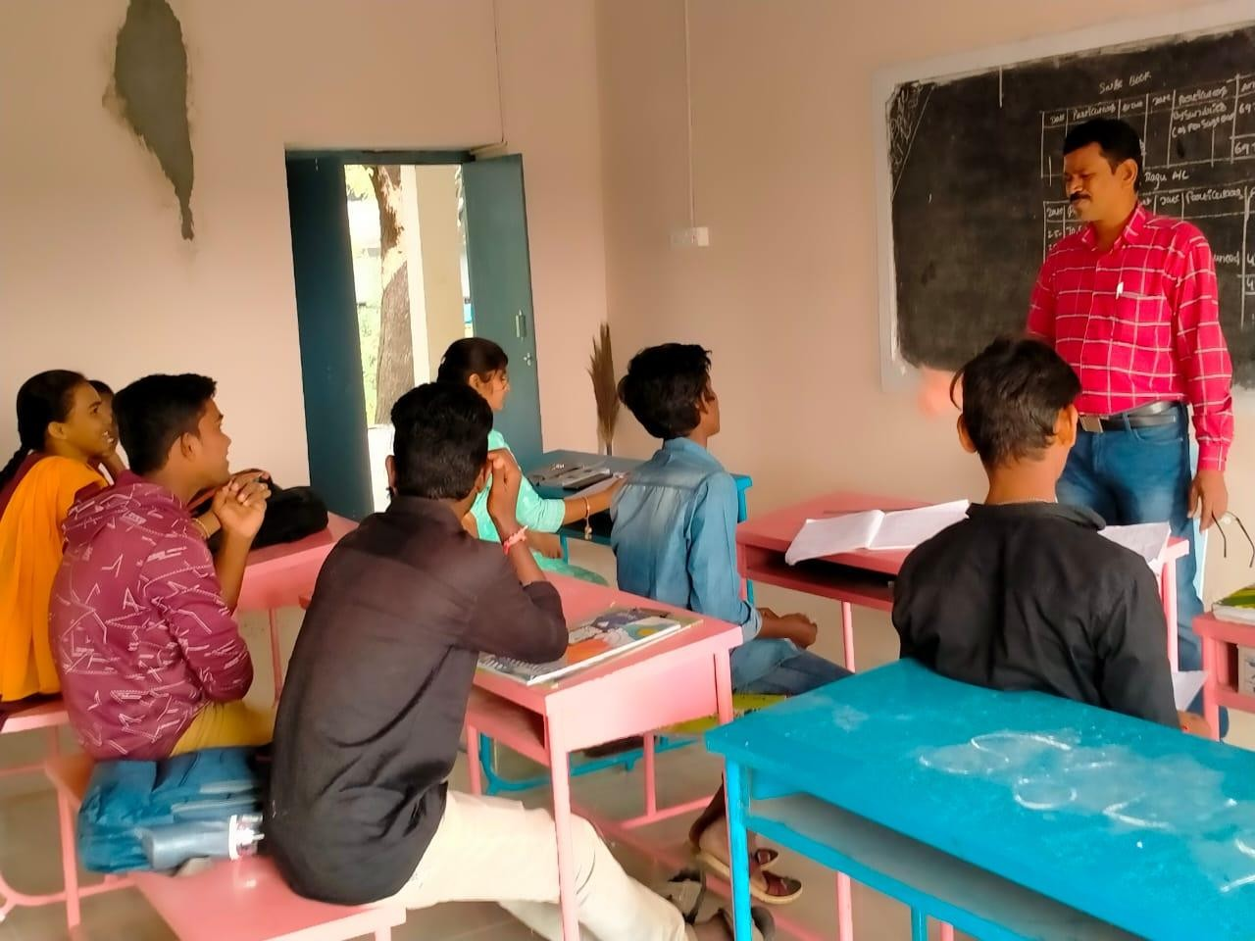
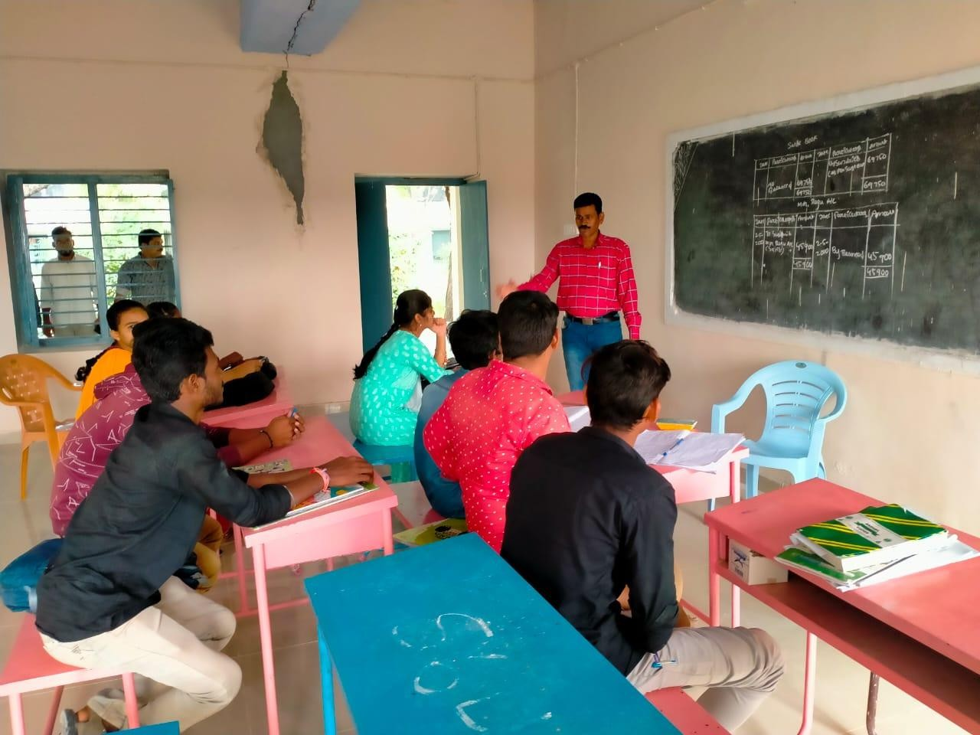

Essay writting
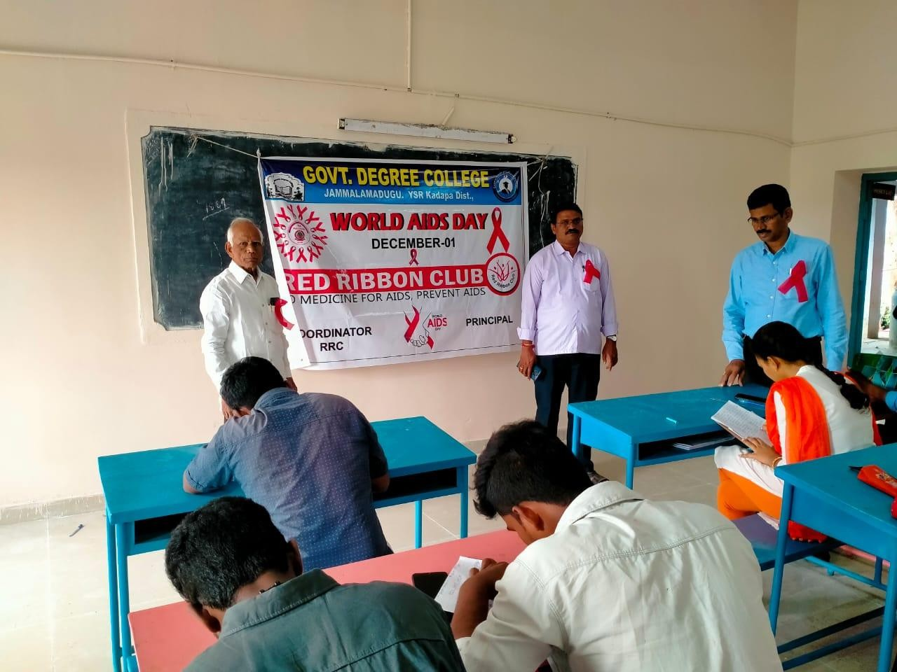
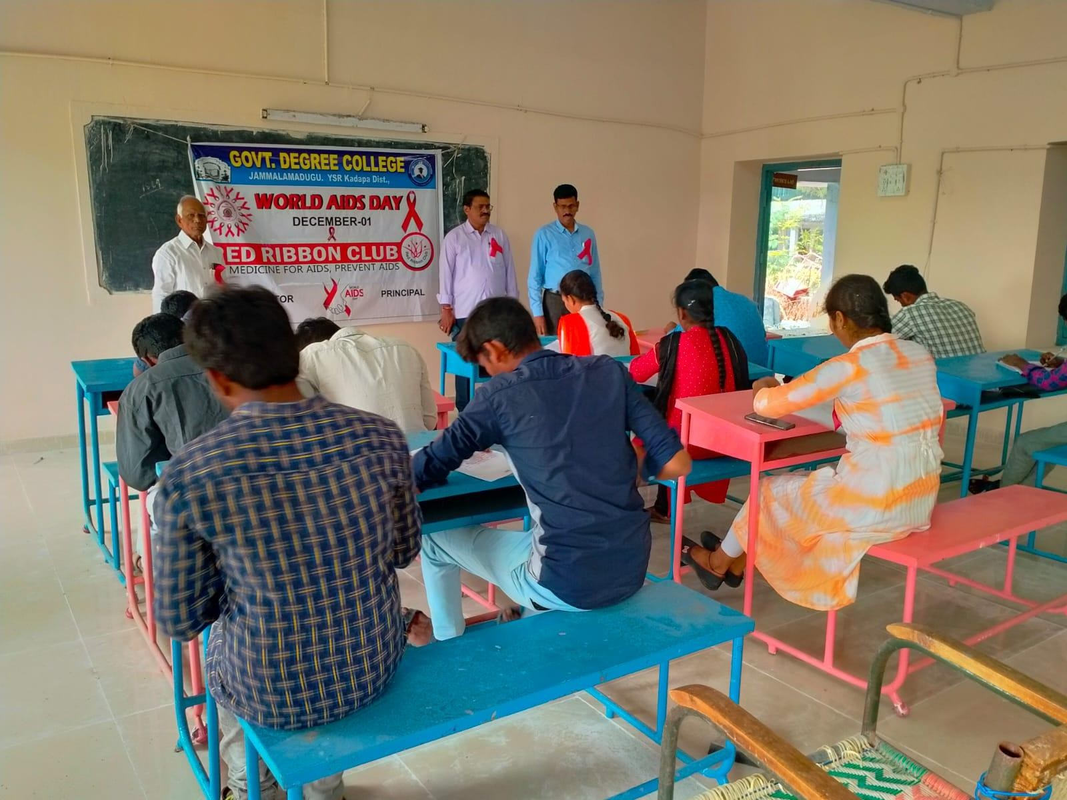

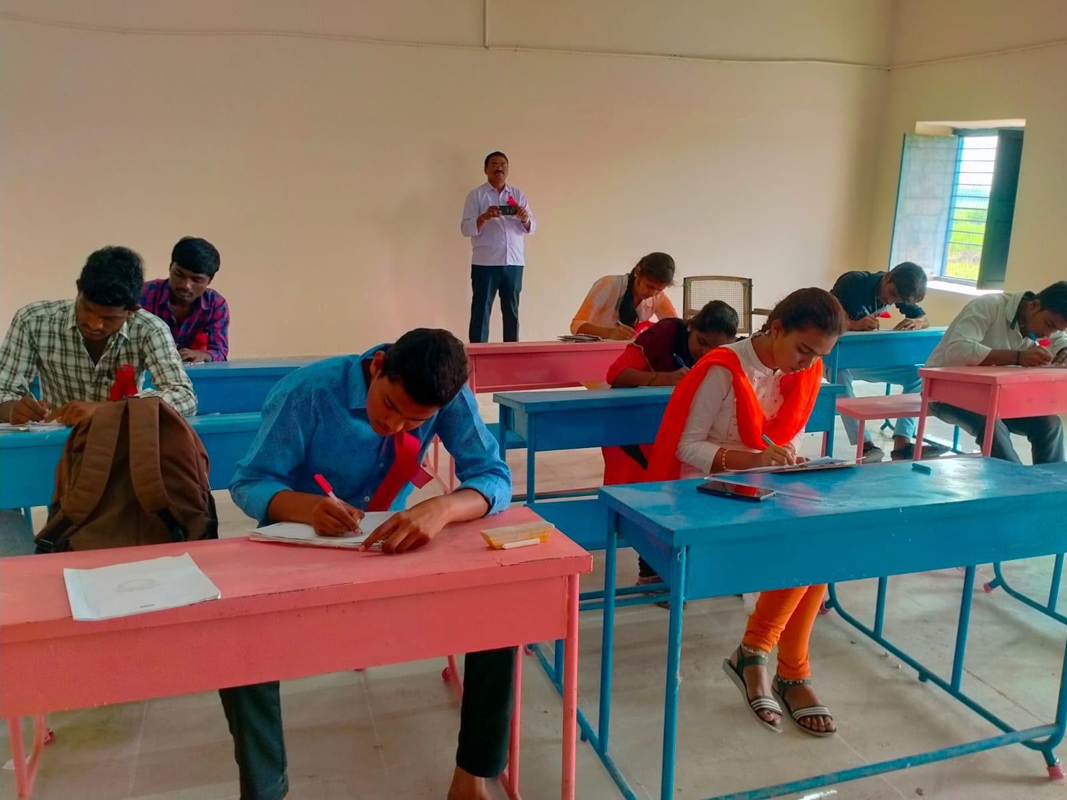
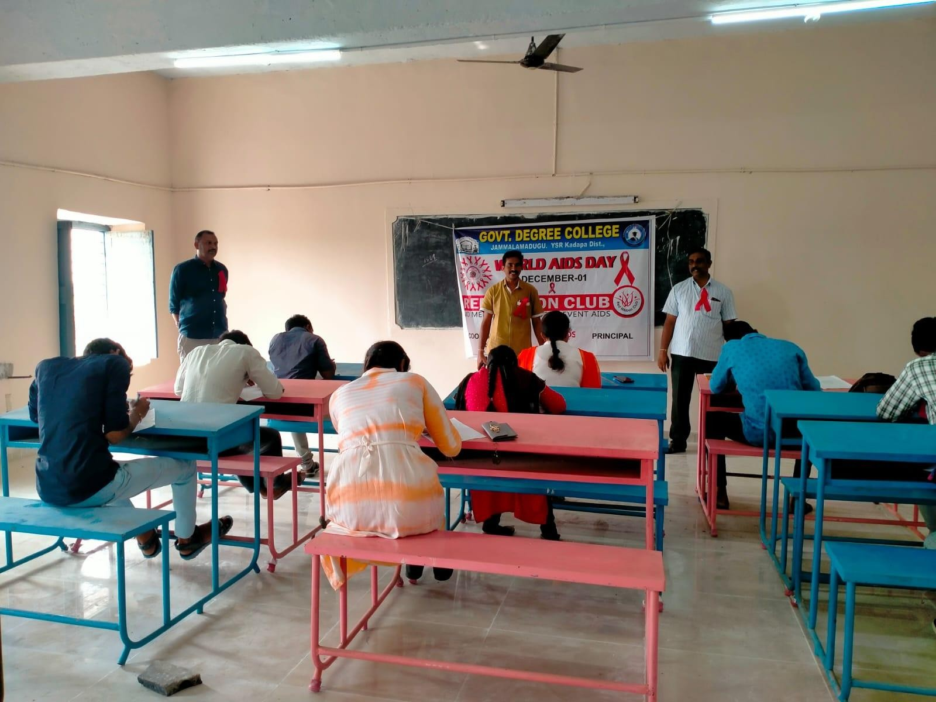

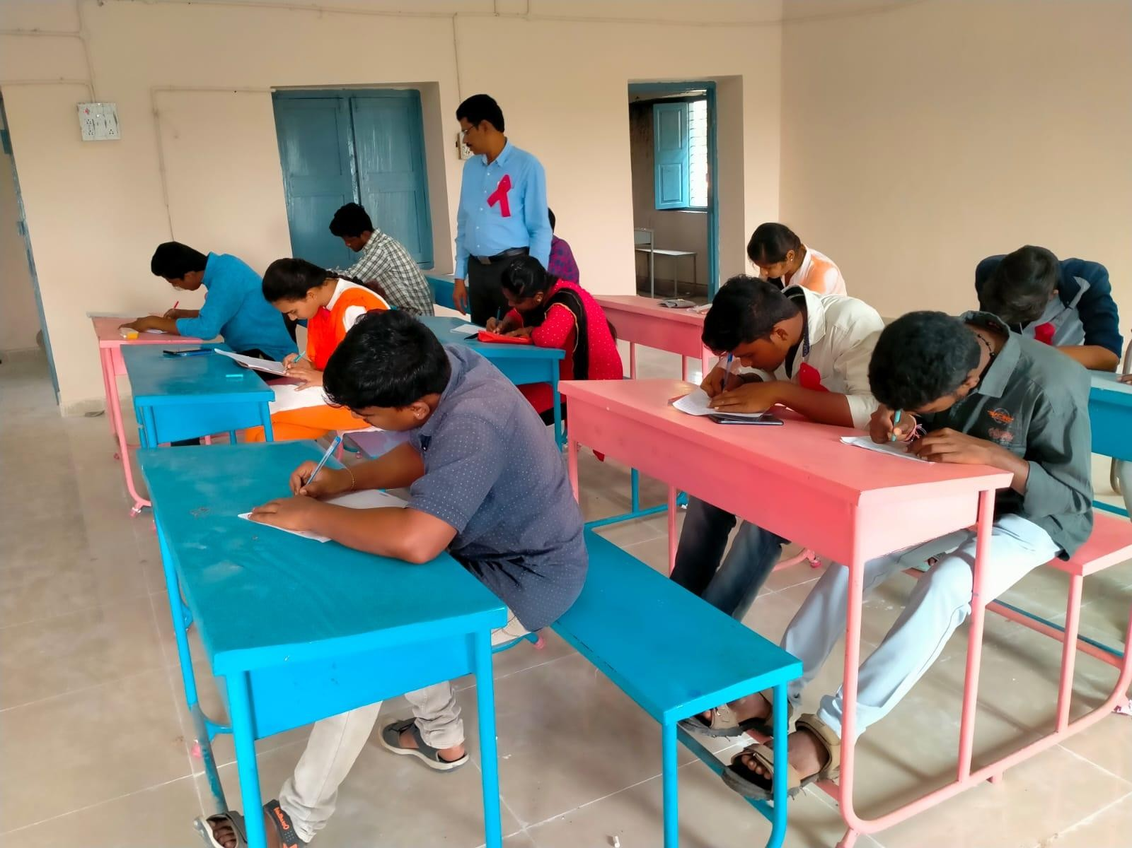

Elocution

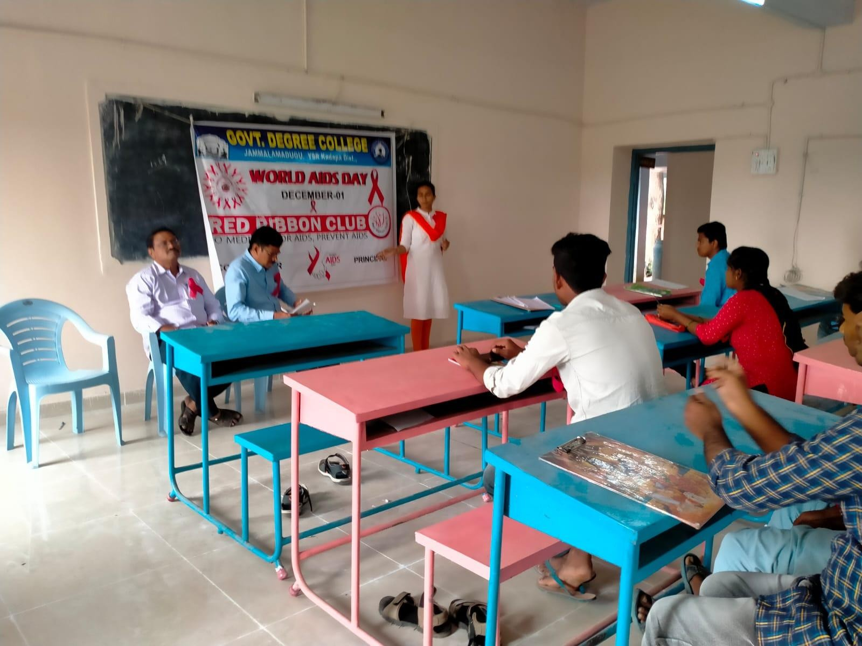
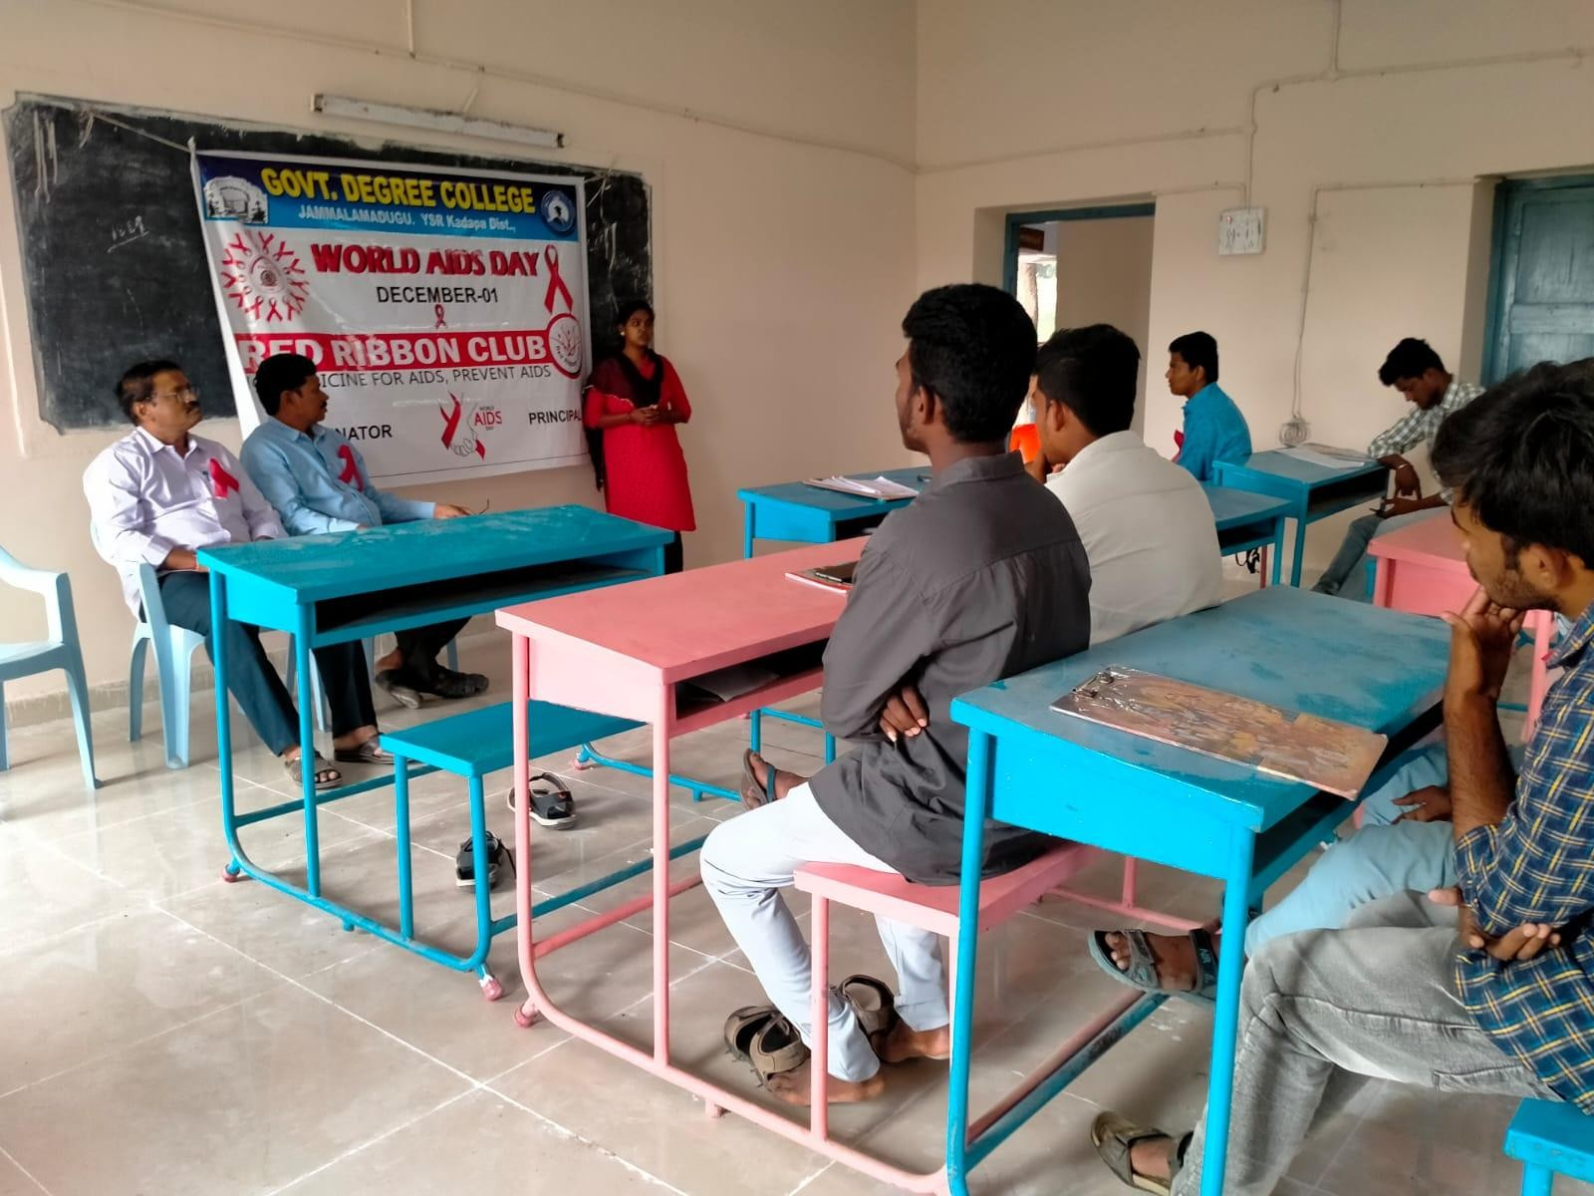

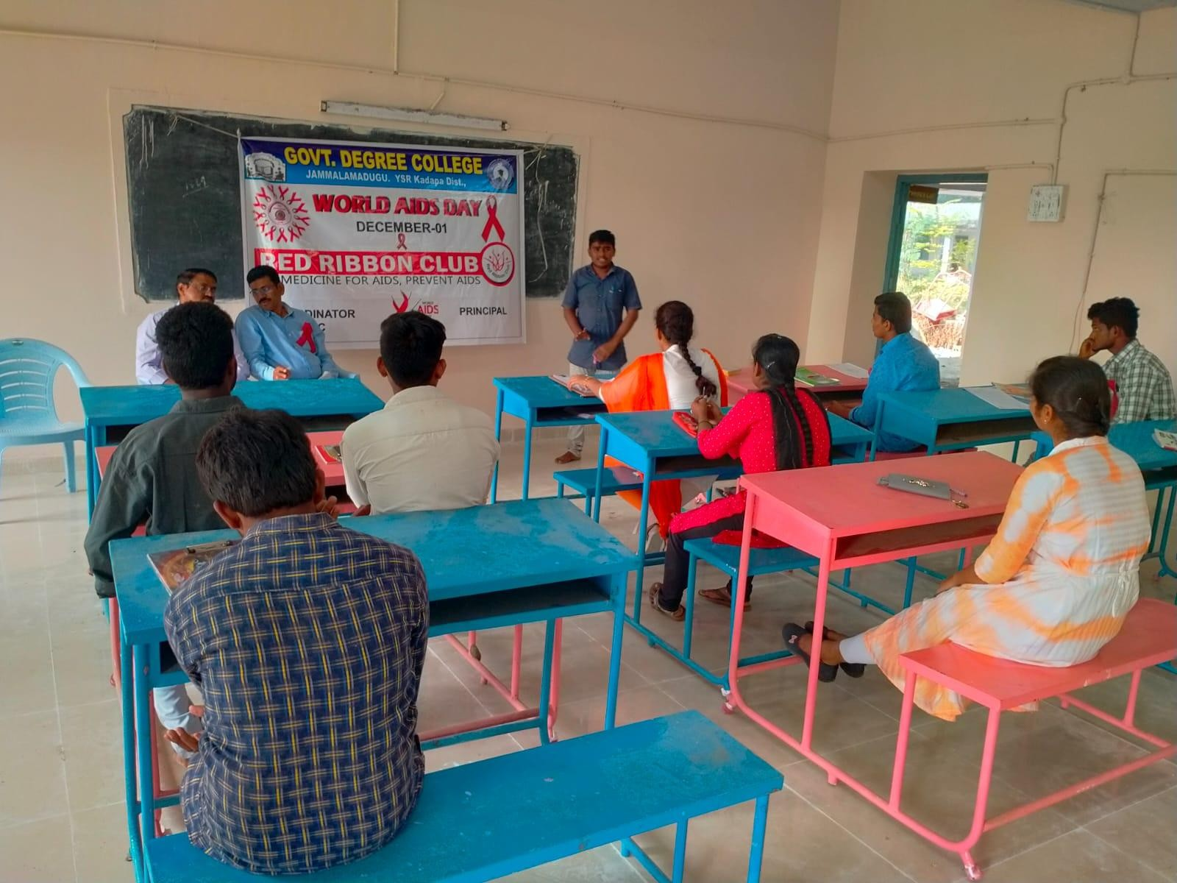
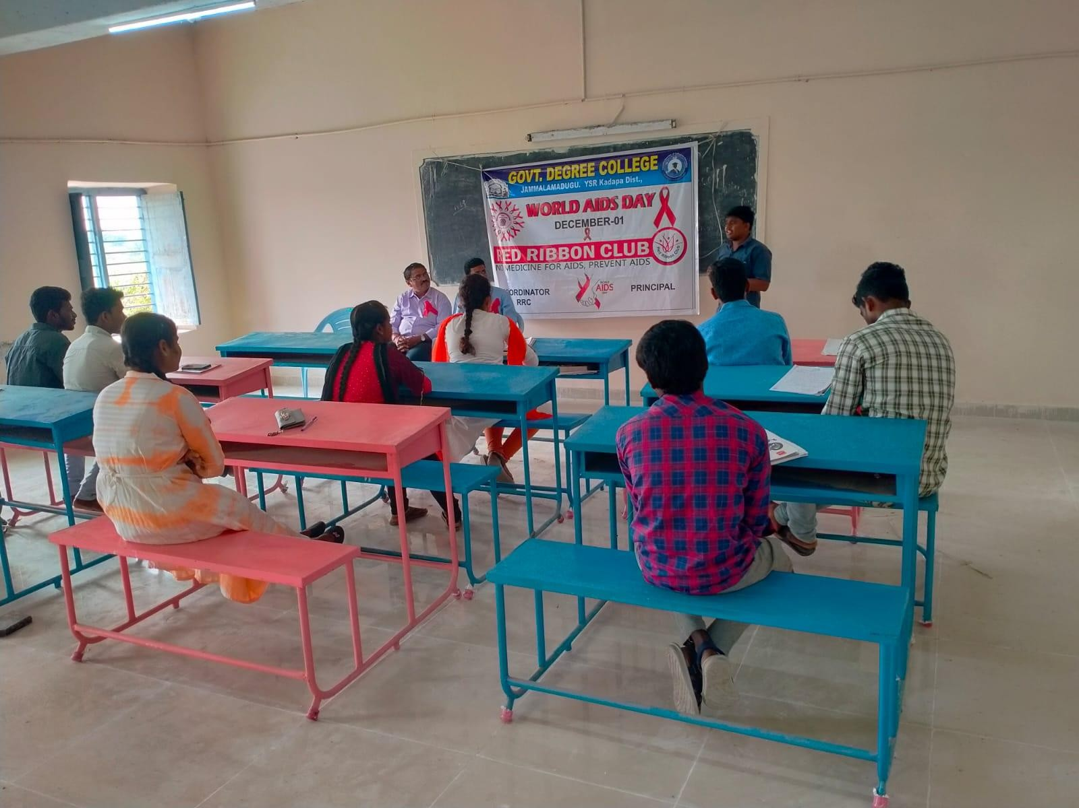

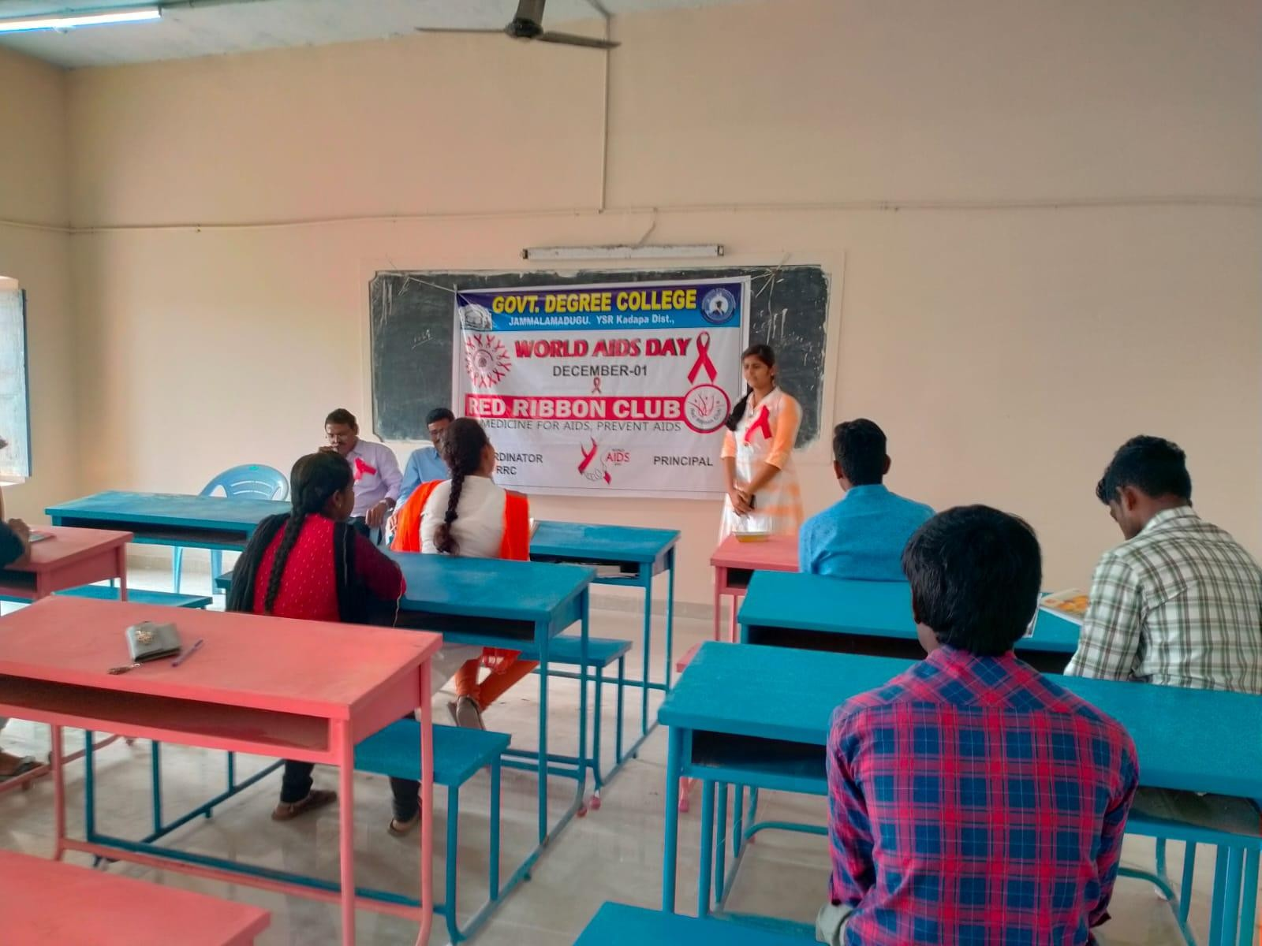

AIDS DAY : 1/12/2024
Pledge

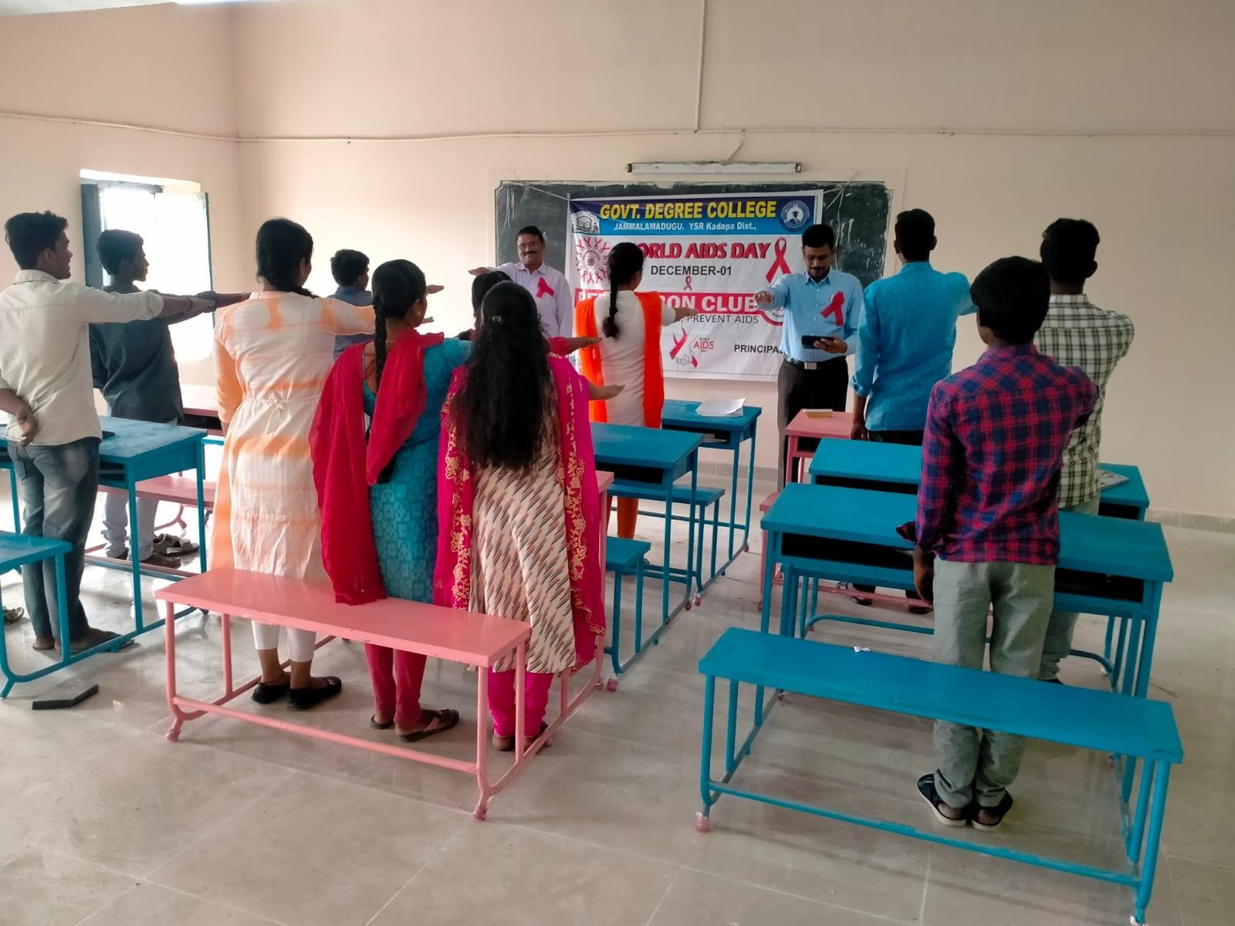
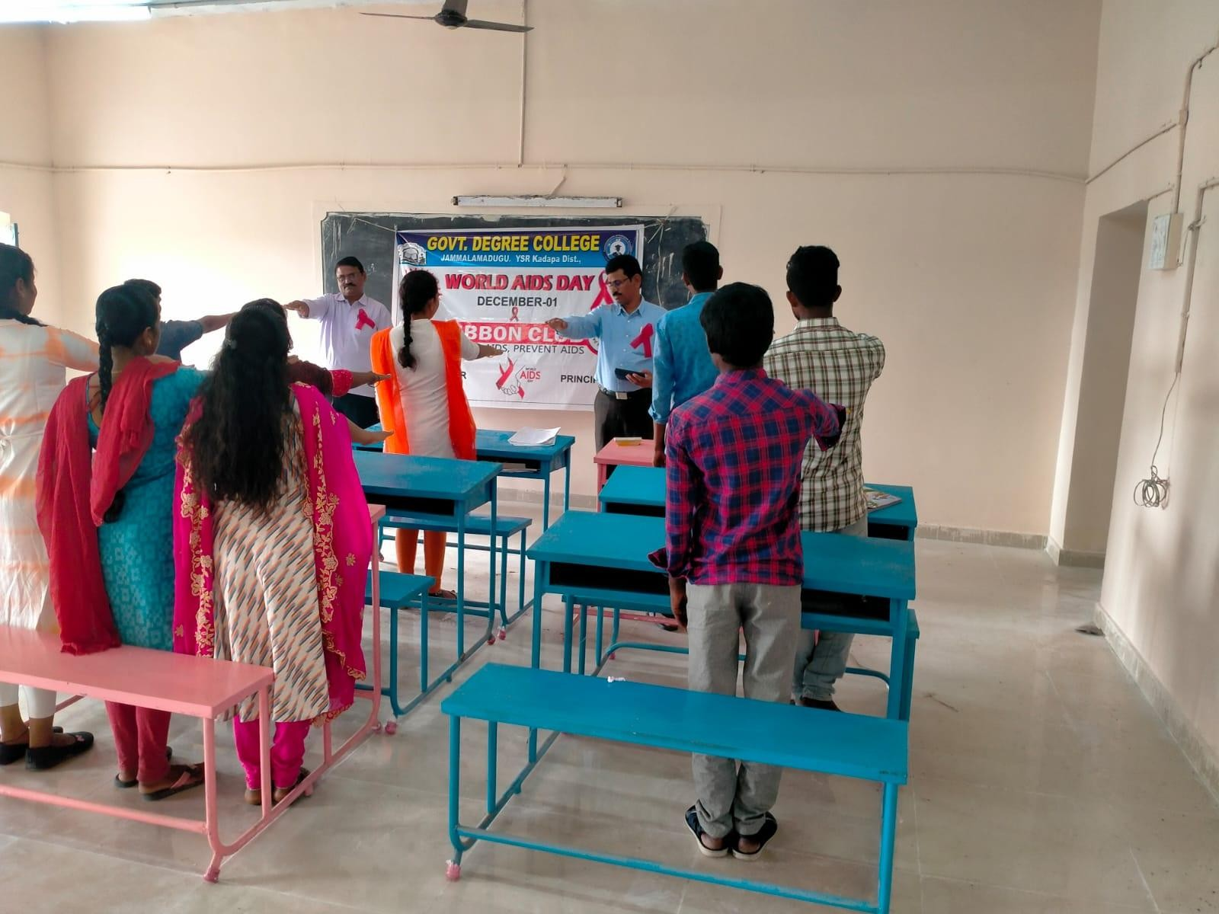

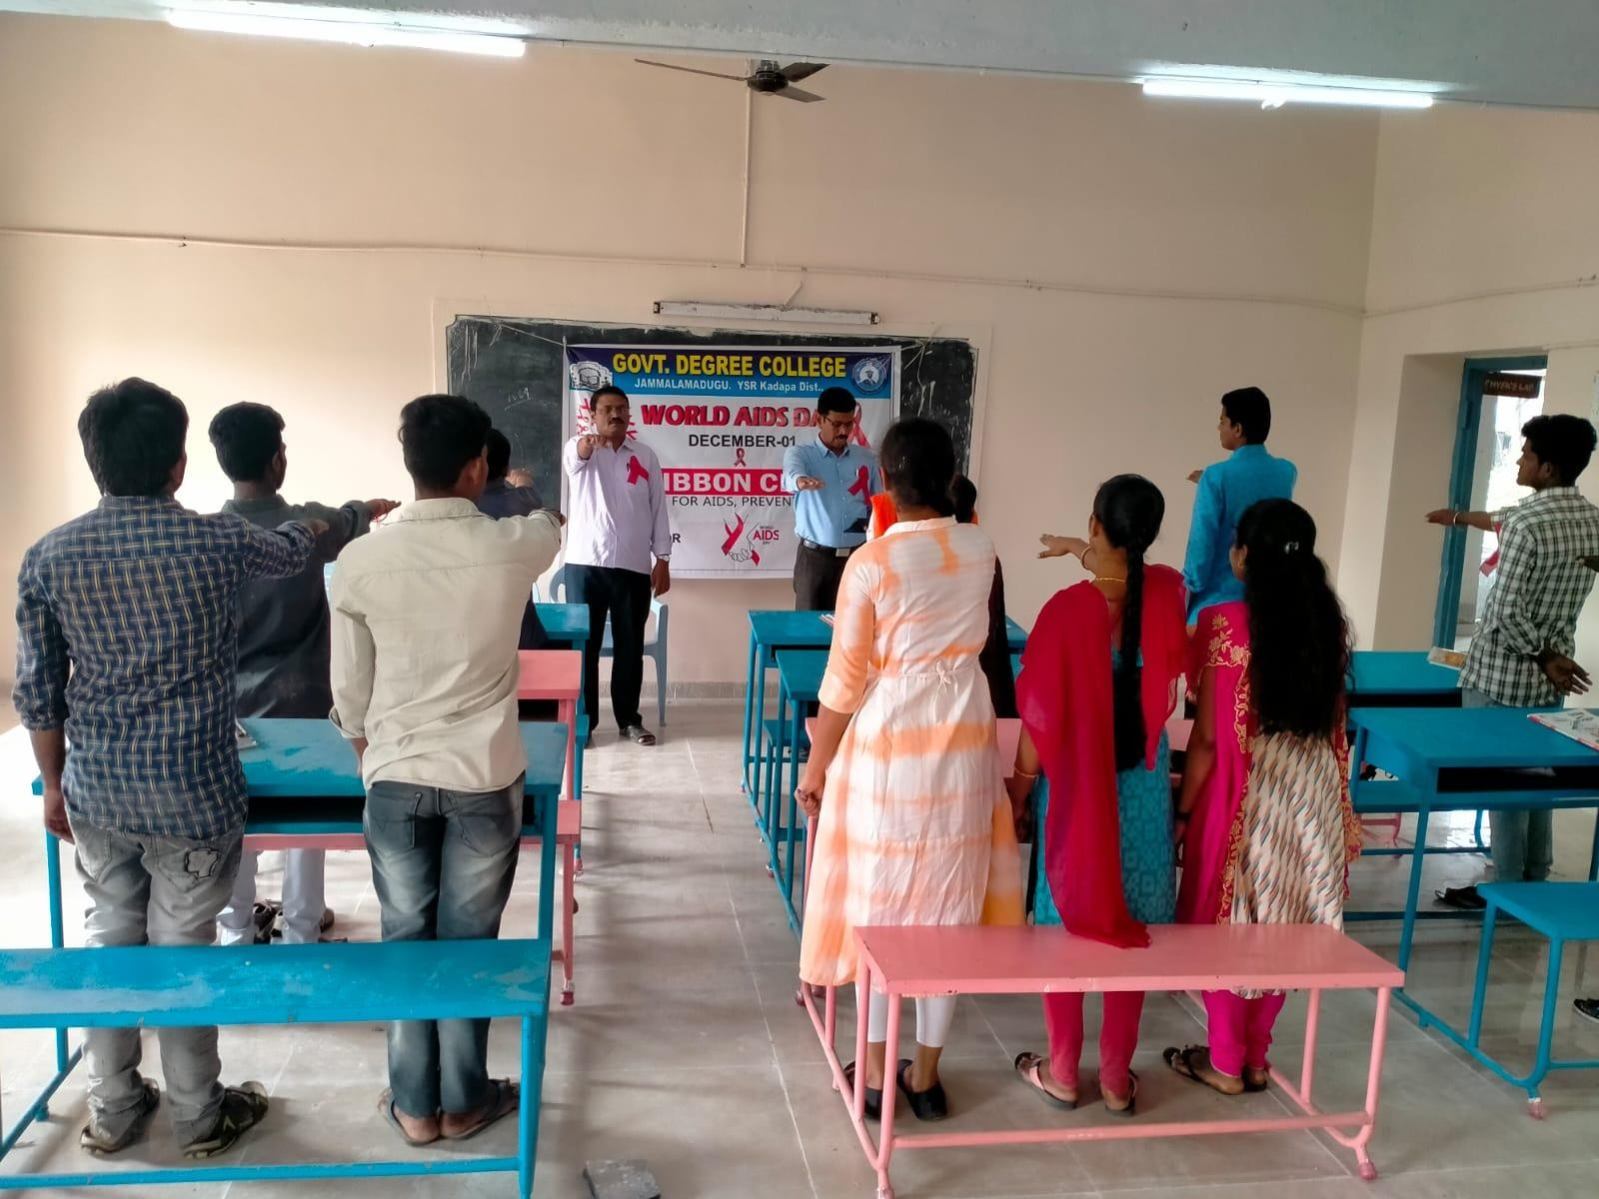
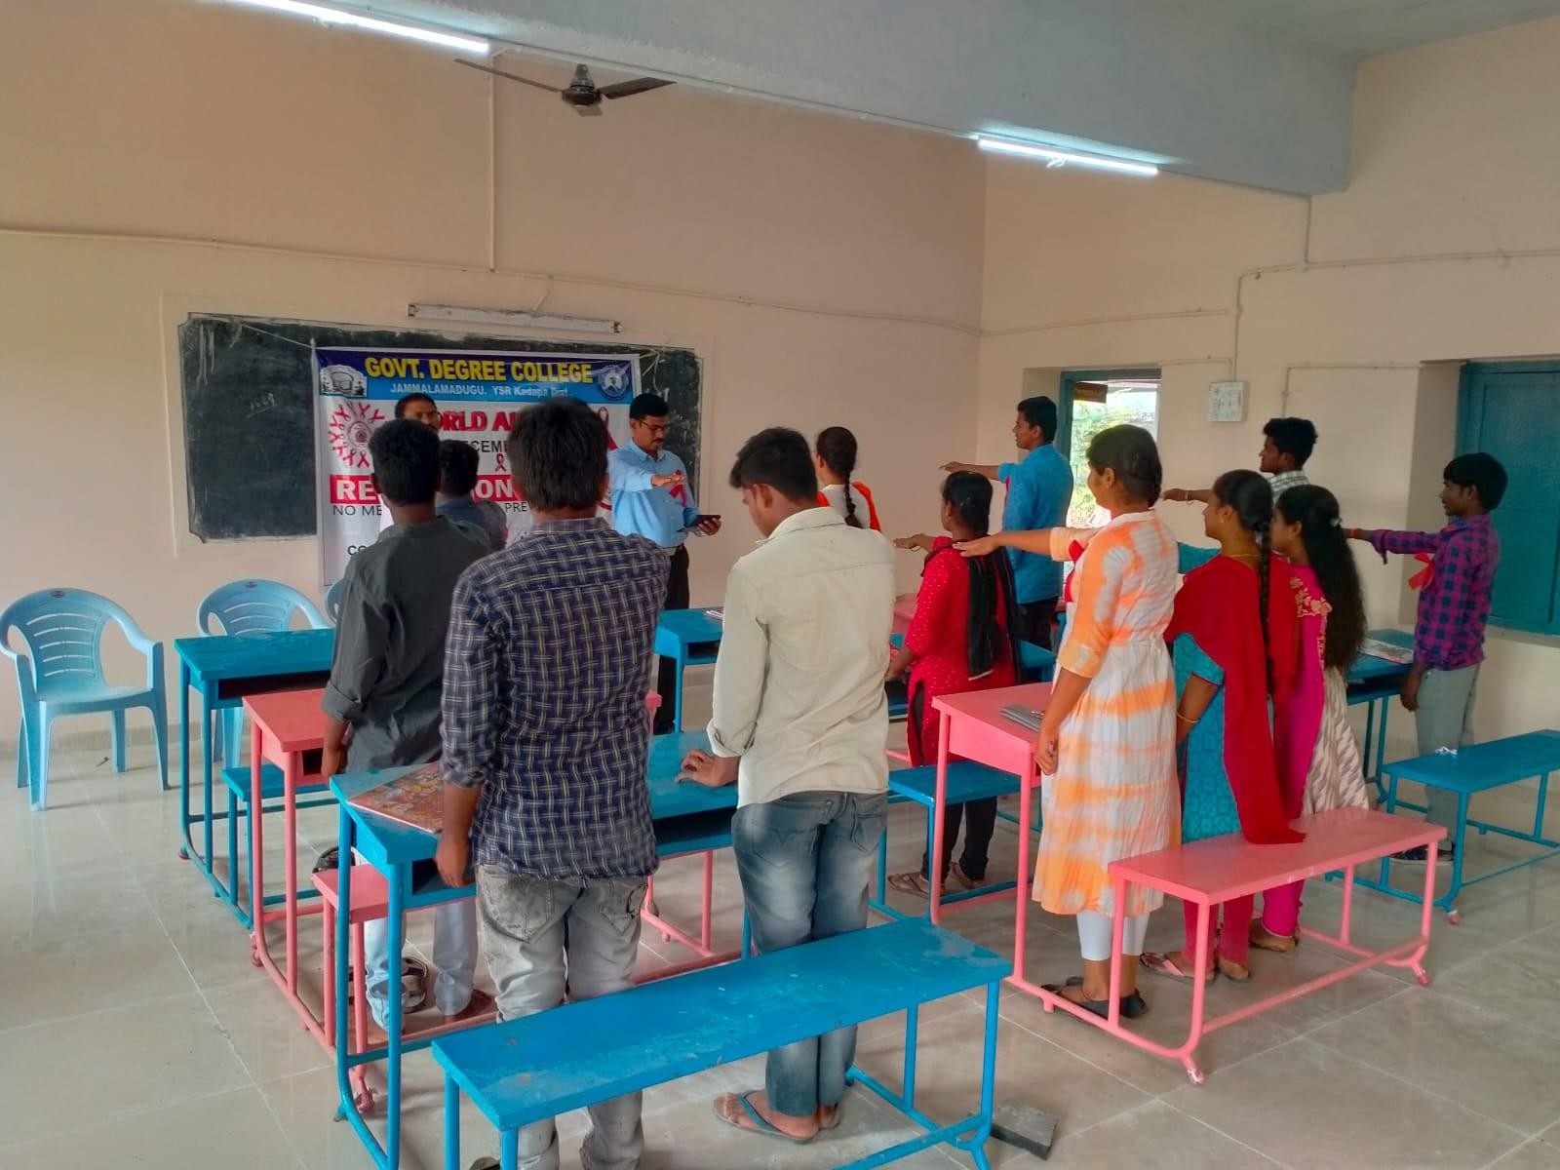

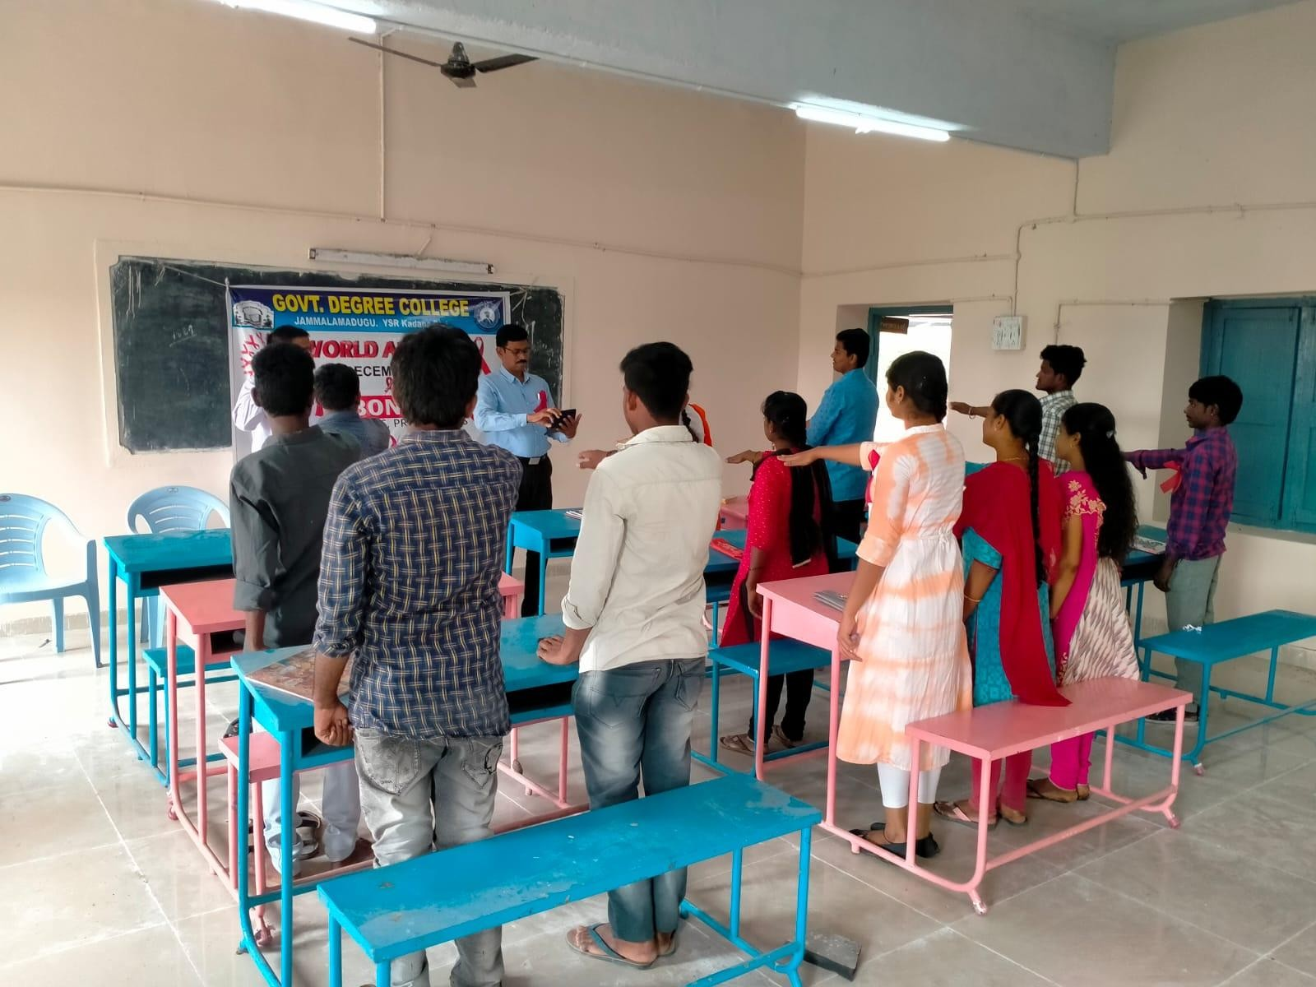

Rally

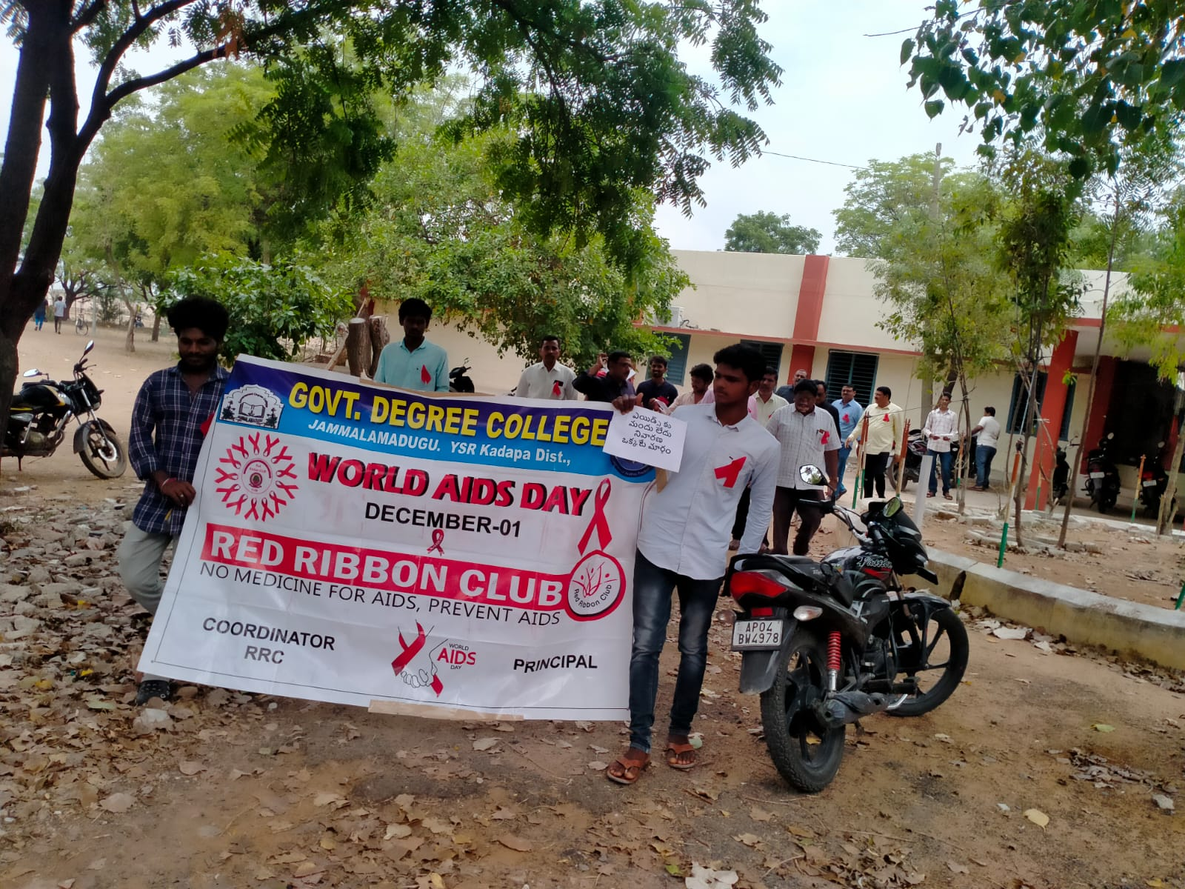
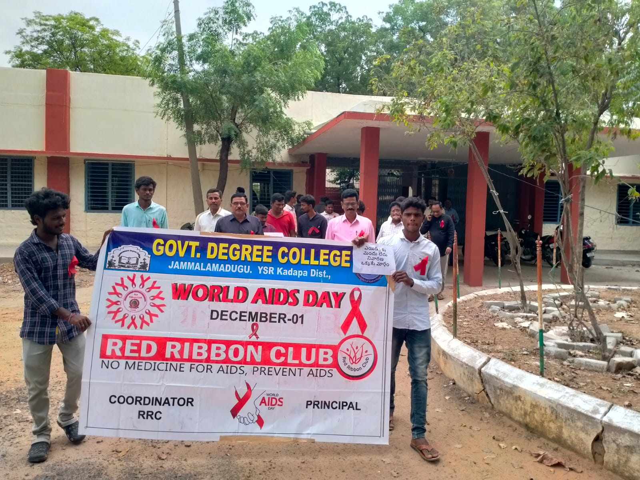

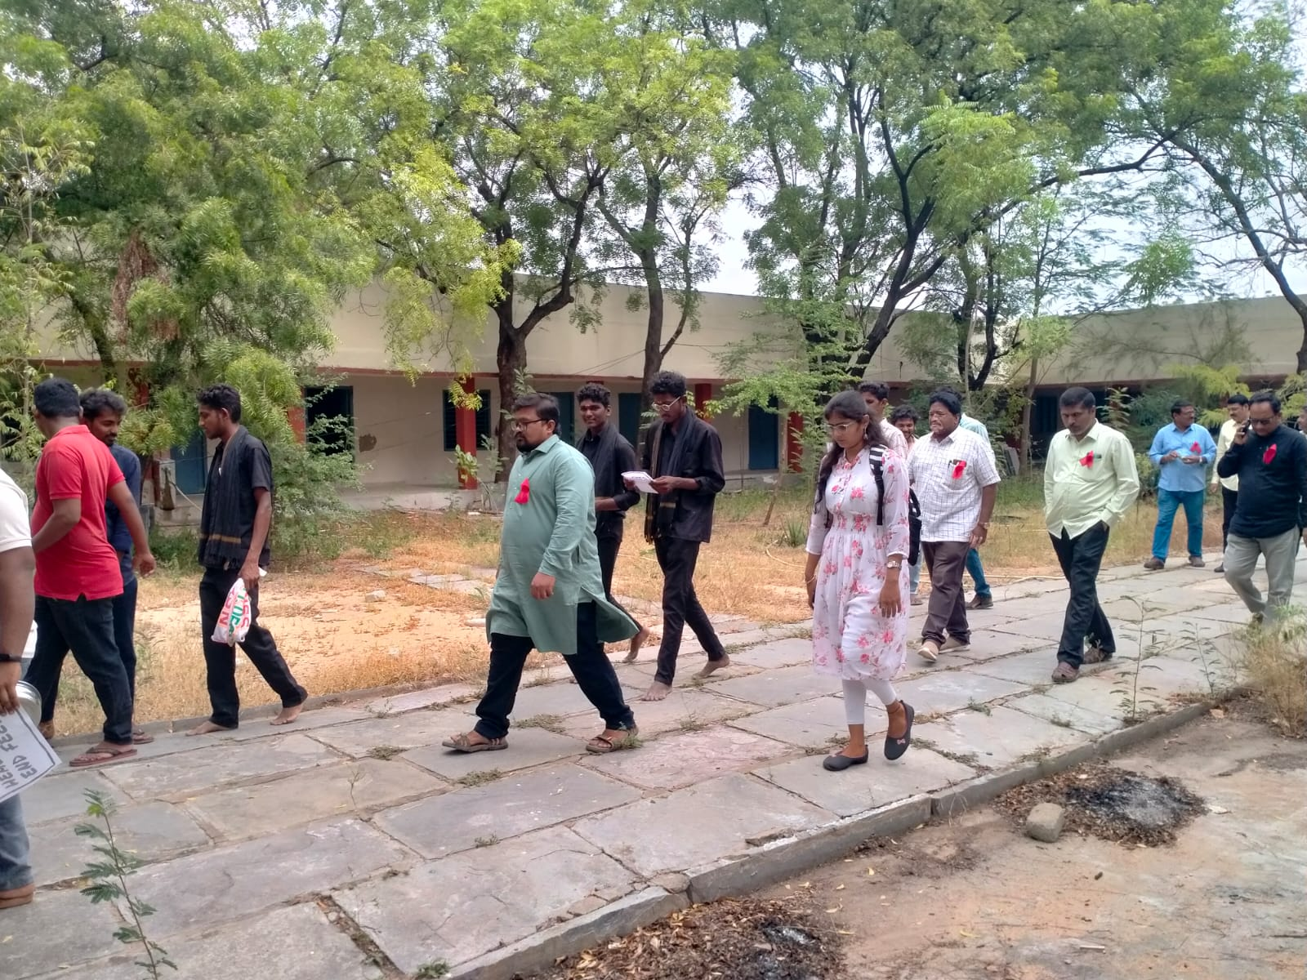
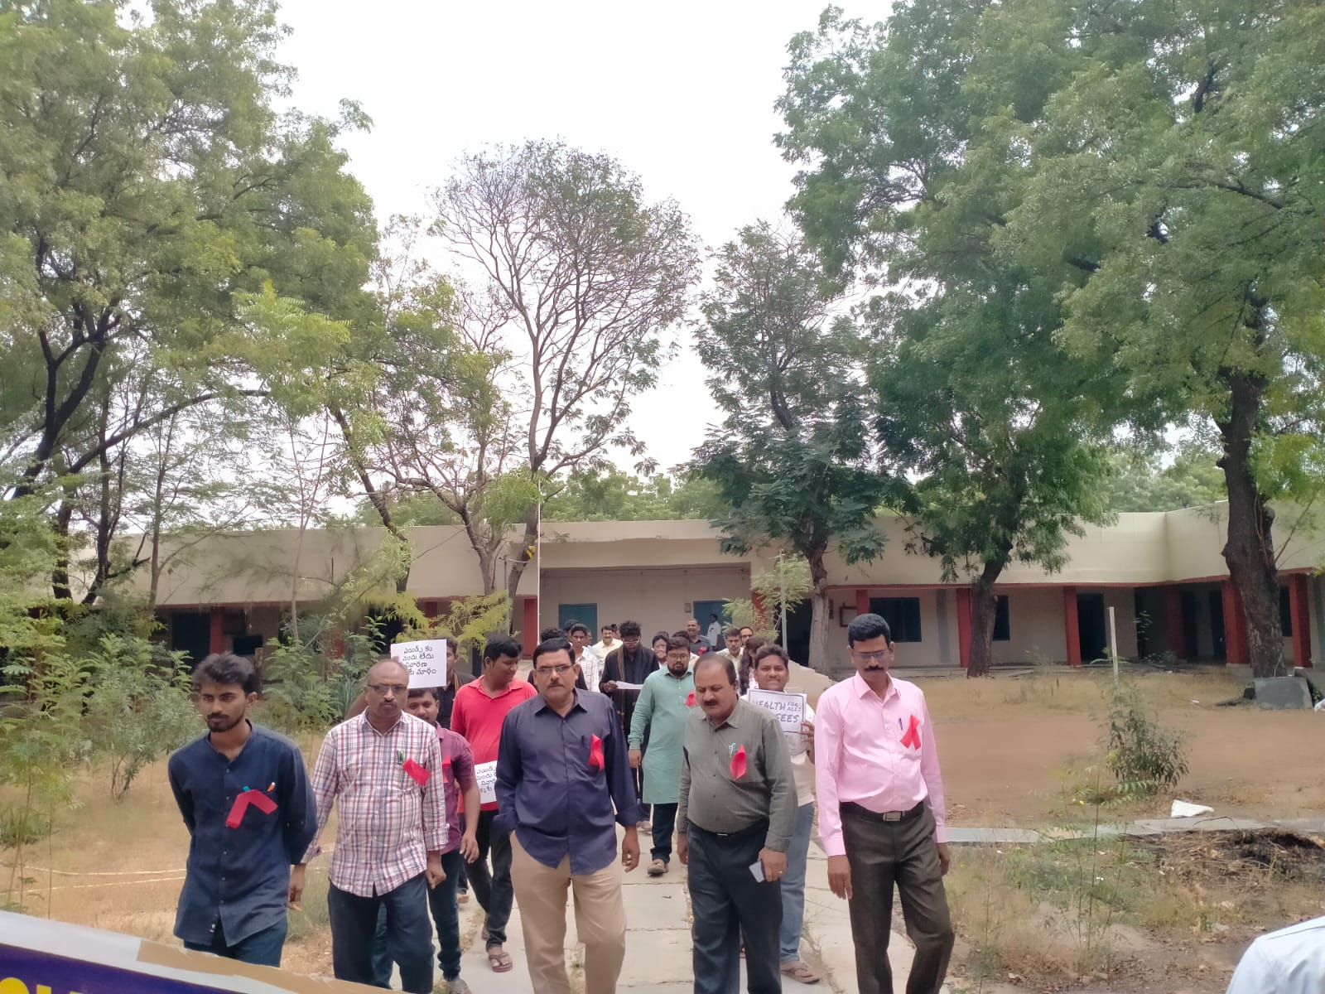

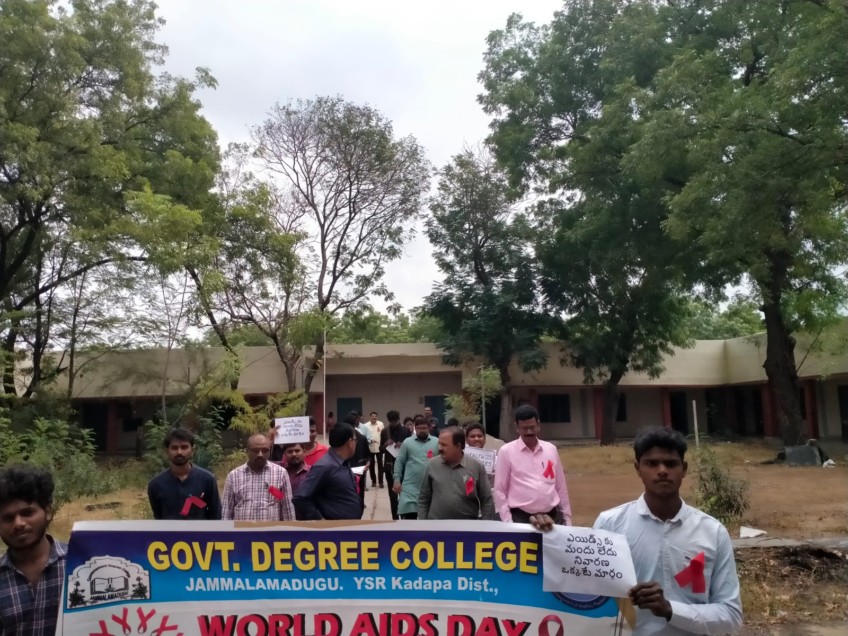
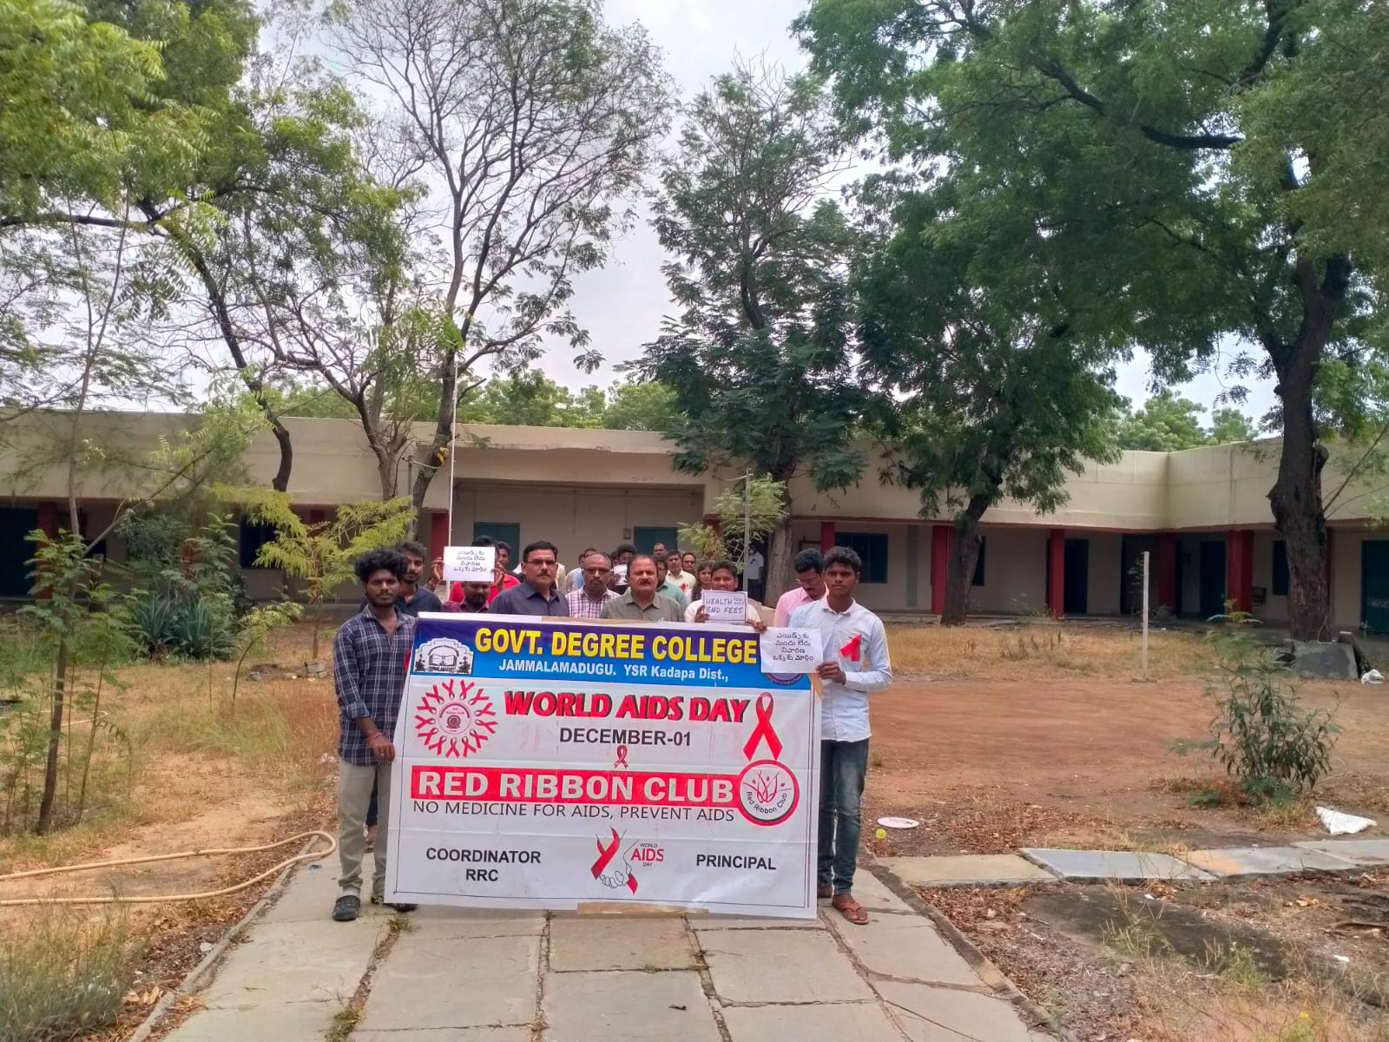

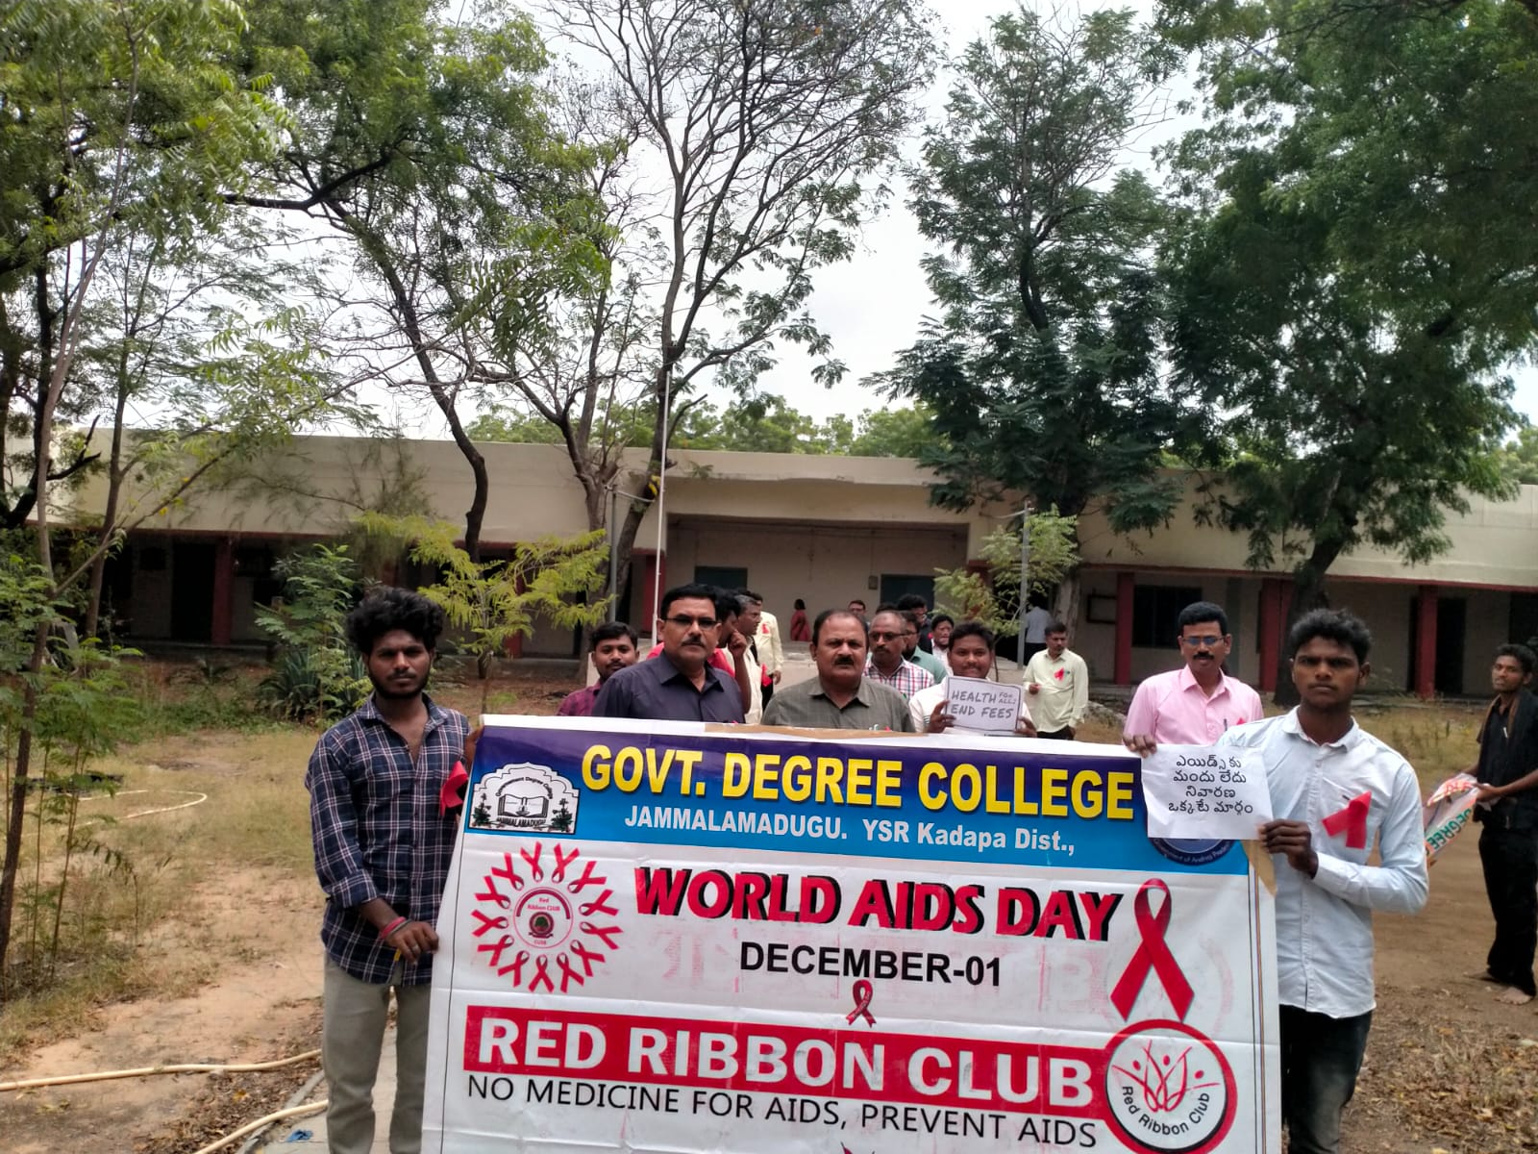
Prizes distribution to winners

